**Computaional approach for analysing the local blood flow in a vascular network at high altitude pressure using neural networks.**

**A.N. SURAJ KUMAR, A. NAVEEEN KUMAR,**

Dept. of Aeronautical Engineering, INSTITUTE OF AERONAUTICAL ENGINEERING, DUNDIGAL,500029

**ABSTRACT:**

Flying at high altitude presents significant challenges for the human body, particularly regarding hemodynamics in the vascular network. In this study, we present a new method using neural networks to analyze local blood flow in vascular networks during flight. Leveraging the power of deep learning, our approach aims to gain a deeper understanding of complex hemodynamic responses in high-pressure environments. Using the properties of blood and its vessels, we design and train a neural network architecture specifically for complex spatio-temporal data processing of vascular networks. The model's ability to learn and expand vascular behavior demonstrates its effectiveness in capturing dynamic changes in blood flow; this can have a significant impact on air medicine and passenger safety during high altitude travel. We also performed a deep neural network analysis to reveal the mechanisms underlying the regulation of changes in blood pressure at different altitudes. This interpretive analysis revealed the role of certain ship geometry, turbulence effects, and ship compatibility in the context of high-altitude flight. These findings promise to improve the safety and health of passengers on high-altitude travel, and may also pave the way for the development of treatment strategies for people experiencing high-altitude-related problems.

**INTRODUCTION:** With rapid development of aviation technology, high altitude flights have become an important part of aviation today. These flights have huge advantages in terms of speed, fuel efficiency and modern flight mechanisms. This comes with a risk of perating at high altitudes which is a challenging environment for a human body to function due to high atmospheric pressure and reduced oxygen. One such disadvantage and challenge comes in the field of haemodynamics i.e the flow of blood in vascular networks. Deviations from normal blood flow patterns can lead to catastrophic effects on human health leading to hypoxia, dizziness, altitude sickness, and cardiovascular complications such as hemmorhage [1]. Thus, understanding the changes blood flow at higher altitudes is very important for pilots and passengers.

In recent years, computational tools are used for investigating blood flow in vascular network as they are highly reliable and efficient way of visualising blood flow as they are non invasive and effectively visualisable. Till date, several investigations have examined the blood vessel structure and floew characteristics from magnetic imaging techniques and CT angiography scans [2]. We know that the vascular network has several variations among different biomedical cases, the visual identifications should not be relied upon as they are not repeated elsewhere. However, the bifurication principles are similar among all vascular networks in human body, it is better to construct models based on these rules of bifurications and area distribution using suitable algorithms and experimental data.

This research paper proposes a novel approach that leverages the capabilities of neural networks that can analyse and predict the blood flow at high altitude by which we aim to gain insights into the physiological adaptations of the human circulatory system and haemodynamic properties at varying altitudes and atmospheric conditions. Several algorithms have been proposed for this solution that use various type of constrains such as volume of blood vessels, pressure and the blood flow is assumed to be laminar using poisuelle’s law[3]. M.Zamir[4], in 1999, did an extensive study in the field of fractal properties of blood vessels and found that that the fractal nature of blood vessels is dependent on the size of the vessel that is they have pseudo fractal properties based on size which can be described through power law index.

Kahveci, K., & Becker, B. R. [5] showed that the the blood flow velocity experiences a significant decrease after the bifurcation points due to the higher total crosssectional area of the daughter vessels as compared to the parent vessel. This decrease in velocity is partially recovered due to the tapering of the blood vessels as they approach the next bifurcation point. The results also show that the secondary flow, which is typical for large arteries, does not develop in small arteries after the bifurcation due to the presence of laminar blood flow with very low Reynolds number in the small arteries. They have used Murray’s hypothesis or the principle of minimum work.

Kopylova et al. [6] in 2019, proposed a mathematical method to determine the fundamental constrains on the vasculature system. To do so, they implemented the basic architecture rules of arterial system in addition to the random pattern for small vessels. As a specific example, they apply the proposed method to the vasculature of rat’s brain. Ac-cording to the results, two main constrains for the reconstruction of vessels network are magnitude of the blood flow and arterial blood volume.

Also, it was determined that the optimum bifurcation exponent should be between 2.9 and 3.0 with the minimum value of 2.7. However, no particular discussion regarding the fluid flow pattern within the modeled network in the tissue was performed. Here for modelling the vasculature, we use data from the previous work and try implement the pressure changes at pulsatile flow. After the vascular system is reconstructed and the CFD results are obtained for various configurations. This data is used to train Generative adverserial neural network for vascular reconstruction and Artificial neurl network for pressure contours.

**GOVERNING EQUATIONS:**

Here, the governing equations used shall be discussed for the network construction and fluid flow solvents. We shall divide this section into two parts i.e., one for the haemodynamic and CFD equations and other for the Murray’s laws.

In context of analysing local blood flow in vascular network during high altitude flight, several governing equations from fluid dynamics and physiology play a critical role in visualising and calculating accurate flow properties of blood flow:

**Navier-Stokes equation:**

Continuity equation:

= 0

Momentum equation:

v is the velocity vector, P is the pressure, ρ is the density of blood, μ is the dynamic viscosity of blood, g is the gravitational acceleration, and ∇ represents the gradient operator. The stress tensor is defined as

Where is the apparent viscosity, Sij is the mean strain rate tensor and is the shear rate defined as a function of the second invariant of Sij in 3D problems 

Where the consecutive parameters of the human blood are given as

0.00348 pas, 0.1518 pas

40.0s, a = 2.0, n = 0.356

**Hagen-Poiseuille Equation**:

This equation describes the flow of an incompressible and Newtonian fluid through a cylindrical vessel. It is often used to model the flow in individual blood vessels where where Q is the volumetric flow rate, r is the radius of the vessel, ΔP is the pressure difference across the vessel, μ is the dynamic viscosity of blood, and L is the length of the vessel.

Bernoulli's Equation: Bernoulli's equation relates the pressure, velocity, and elevation of a fluid along a streamline. It is applicable when the flow is steady, incompressible, and there are no external forces acting on the fluid:

where P is the pressure, v is the velocity, ρ is the density of blood, g is the gravitational acceleration, and h is the height above a reference level.

**BRANCHING PROPERTIES:**

he branching of a parent vessel into two child vessels or micro-vessels can be identified by introduction of the some parameters including the bifurcation index (α), the area ratio (β) and the power index (λ). The bifurcation index is defined as the relative radius ratio of the child vessels after bifurcation (Eq. (1)):

α=r2 / r1

where r1 and r2 are the radius of childs’ diameter and as r1 belongs to the larger vessel then 0< α≤1. Moreover, the combined area of the child vessels relative to the parent vessel is defined as the area ratio according to Eq. (1) as:

β=r12+r22/r02

where r0 is the parent radius. In bifurcation process almost in all of the bifurcation instances, the overall area of the child vessels is higher than that of the parent vessel (i.e. β≥1), however in some cases for small vessels bifurcation, the β≤1 is also observed. Another constitutive relation between the size of the vessels up and downstream of the junction is the power index: r0λ=r1λ+r2λ(3)

The λ index can take values between 2 and 3 according to the assumed optimization criterion and the mass conservation law. In limiting cases, as the value of three for λ (cubic law) is taken, it is assumed that the required energy for blood transport is minimized or the shear rate at various parts of the bifurcation is invariant. On the other hand, the square law (λ=2), emphasize the constant total area passing through the junction of vessels. However, it should be noted that according to the experimental observations none of the mentioned assumptions are exactly correct and the occurrence of a wide range of power indexes at any bifurcation level is possible.

**NEURAL NETWORKS:**

An artificial neural network (ANN) is a computational model inspired by the human brain's neural structure. Comprising interconnected layers of artificial neurons, it processes data through weighted connections, each neuron transforming input signals and passing them to the next layer. During training, the network adjusts its weights to minimize errors and learn patterns from input-output pairs. ANNs excel in complex pattern recognition, classification, and regression tasks, with applications in image and speech recognition, natural language processing, and more. The parallel processing and adaptability of ANNs enable them to tackle a wide range of problems, contributing to advancements in artificial intelligence.

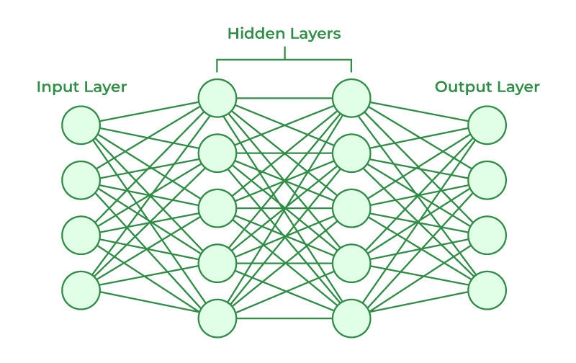

The structure of a neural network refers to its architecture or arrangement of layers and neurons. The most common type of neural network is a feedforward neural network, which consists of three main types of layers:

Input Layer: The input layer receives the raw data or features as input. Each neuron in the input layer represents a feature or input variable. The number of neurons in the input layer is determined by the dimensionality of the input data.

Hidden Layers: The hidden layers are intermediate layers between the input and output layers. They perform the essential computation and feature extraction. The number of hidden layers and the number of neurons in each hidden layer can vary depending on the complexity of the problem. Deeper networks with more hidden layers can capture more complex patterns but may require more data and computational resources

Output Layer: The output layer produces the final result or prediction based on the processed information from the hidden layers. The number of neurons in the output layer depends on the type of task. For example, in binary classification, there will be one neuron representing the probability of one class, while in multiclass classification, there will be multiple neurons, one for each class.

Each neuron in the hidden and output layers is connected to every neuron in the previous layer. These connections are associated with weights that determine the strength of the connections. During training, these weights are adjusted iteratively using optimization algorithms to minimize the difference between the predicted output and the actual output (loss function). The activation function is applied to each neuron's output in the hidden and output layers to introduce non-linearity into the network. Common activation functions include ReLU (Rectified Linear Unit), sigmoid, and tanh.

**GENERATIVE ADVERSERIAL NEURAL NETWORK**

Generative Adversarial Networks (GANs) are a class of artificial neural networks designed to generate new information similar to the information given. GANs have two main components: generator and discriminator. The generator creates a synthetic data model, while the controller tries to separate the real data from the generated data. Both train simultaneously in competition.

During training, the generator continues to improve its ability to produce more accurate data as a discriminator, and the discriminator will become better at distinguishing real data from fake data.

These competing techniques lead GANs to generate high-quality synthetic data. The GAN is widely used in many fields such as image processing, transformation analysis and data processing. They are used to create realistic images, create graphic images and even create real medical images. Despite their potential, GANs can be difficult to train and may suffer from crashes (engines with low standards) or instability during training. Yet GANs are at the forefront of generative modeling and cutting-edge research in AI.

**METHODOLOGY:**

The flow of research methodology is described in the following steps:

1. Collecting numerical data i.e the flow field characteristics of blood flow such as pressure drop and velocity at the parent and children vessel branches for possible configurations (dihedral angle of 30°,60°,85°, )
2. Training the neural networks to estimate the pressure drop and mean velocity on the provided CFD data to predict the values of future children nodes
3. Training the Generative Adversarial Neural Networks (GANs) using different datasets of vascular network images, such as medicals scans or simulated data( We used simulated data ).
4. Here, there are two parts of the network that is the Generator and Discriminator. The Generator learns to synthesise vascular networks that create results or images that resemble the simulated inputs. The discriminator provides feedback as trues and false and improves the quality and similarity of the generated vascular networks. Combining the results of these two neural network outputs to create pressure contour output.

**Boundary conditions:** Boundary Conditions used in the Ansys Fluent solver to calculate the pressure drop at different children outputs:

3D transient state non Newtonian form of governing equations

|  |  |
| --- | --- |
| Viscosity of blood | 0.0043kg/m-s |
| Density of blood | 1060 - 1070kg/m3 |
| Density of arterial wall | 1200kg/m3 |
| Velocity of blood considered (steady state) | 0.8m/s |
| pressure | 3127pa |

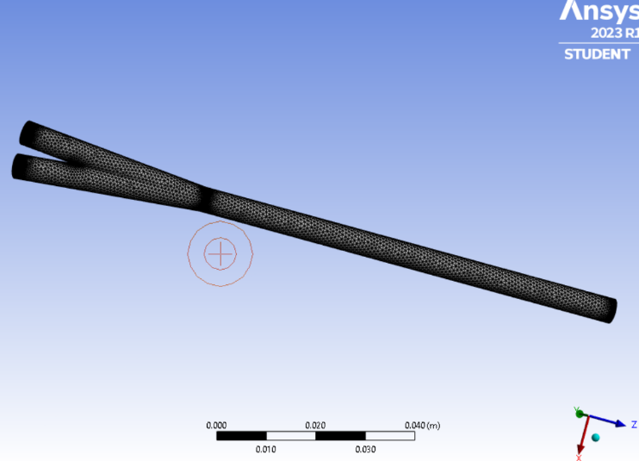

**RESULTS AND DISCUSSIONS:**

The Vascular network:

* The GANs neural network provided the result of comprehensive simulation of vascular system i.e., the structure of the vascular tree and the assignment of the children diameter. The parent vessel is divided into two children accordingly by the inputs taken from the work of M. Zamir on arterial trees.
* The divergence of area ratio and branching exists minimally and the vessel tree is colour graded according to the radii of the vessel.
* As it can be seen, a nearly symmetrical distribution is obtained for vascular system propagation in the y and z direction (in a plane normal to the main vessel direction). However, the density of the nodes in the x-direction is not uniform and a gradual increase in the density number toward the targeted zone, followed by a sharp reduction in density number for farther nodes (due to the successive bifurcation to vessels with short length) is observed.
* The uniformity of the distributed blood feed nodes in the normal plane to the main vessel in addition to the higher density of nodes at specific locations along the main stream are the major characteristics of the produced artificial vascular system
* Besides, the 3D structure of the vascular tree is created by rotation of the bifurcation plane by 90◦after each segmentation (i.e., at each branching step the children vessels are growing in a plane perpendicular to the parent plane). To emphasize on the growing nature of the proposed structure, the growth timeline at various bifurcation level of microvessels are revealed in Fig below

|  |  |
| --- | --- |
|  |  |
|  |  |
|  |  |
|  |  |

**Branching pattern of micro vessels along x and y axes(micrometer)with various number of micro vessels**

**CFD RESULTS AND DISCUSSIONS:**

Computational softwares such as ansys fluent and python libraries such as tensor flow have been used to compute the fluid behaviour in the given boundary conditions. As we considered arterial flw inside the vascular network we considered parabolic inlet velocity over a time period with viscosity of blood being 0.0043kg/m-s and density of blood being 1060kg/m3. The results show a parabolic inlet and exit velocity which is varying along the radius is seen.

At parabolic flow flow is considered to be transient in nature ie its varying with time and distance. During the flow simulation, the macimum velocity across the pipe is assumed to be the sum of squares of the axis that the flow is perpendicular to. Here we assume the flow in z axis then

umax = x**2+y**2

u_transient = umax*(sin(omega*time)*0.1-1)

That is u_transient is unitless. It should be noted that according to the boundary conditions, a uniform flow is assigned at the inlet of feed vessel an due to the sufficient length from inlet to the junction, FD pattern is also created at before the bifurcation location. Moreover, it should be noted the accurate estimation of the pressure drop at the junction of vessels, which is unneglectable compared to the pressure drop in the vessels, is one of the major useful aspects of the present algorithm to obtain a realistic flow distri-bution in the examined tissue.

|  |  |
| --- | --- |
|  | The pressure and velocity contour experimental |
|  | The velocity contour obtained through computational techniques from ansys Fluent software |

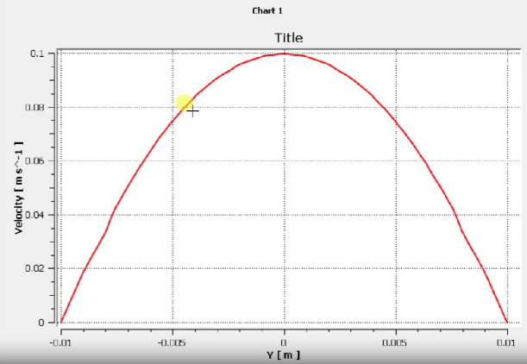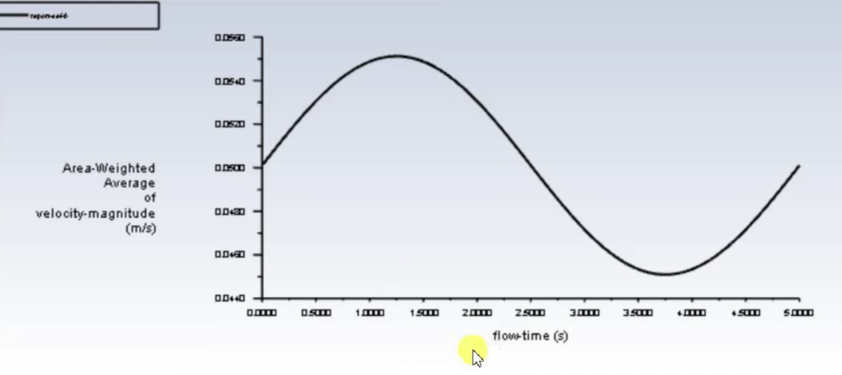

1. Mesh of a bifurcated artery model of 30 degree angleb
2. Residual curve for a parabolic transient flow
3. Velocity vs radius curve of a paraboloc flow

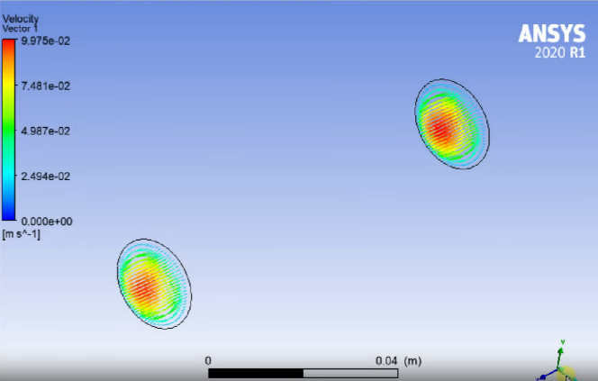

**NEURAL NETWORK DATA ACQUISITION:**

75% of the extracted data was used to train the algorithm, and the rest was used to evaluate the accuracy of recommendations on untrained data. Training data included the shock of two juvenile arteries and the average velocity of one of the outlets. The average velocity at the other end of the bifurcation can be directly calculated using the flow velocity, the estimated value of the initial downstream, and the law of conservation of mass. It can be seen that the predictive ability of the neural networks is obtained for the above three sets of input data and there is a good correlation between the forecast output and the results (see Figure 10).The magnitude of the estimation error, R2, and the standard error are also shown in Figure 10. In addition, according to Figure 10-a, the normal error distribution is obtained as a target and cannot be calculated. Liver distribution in tissue samples is shown in Figure 11. Simulate the standard pressure in the tissue (each point represents the pressure at the end of the branch of the artery). 11. Obtaining the distribution is based on the production of the vasculature distribution from the main vessel to the microvessel level. In addition, the basic assumptions are removed in the analysis of the pressure distribution and the results are based directly on the results from the CFD simulations. Therefore, it is very expensive, if not impossible, to determine a top position for the number of ships used (e.g., 41,736) using direct CFD tests. As a result, pressure drops from the mother's main blood vessels to the target microvessels that send blood to all areas of the tissue. In addition, the resulting tree was found to expand in the tissue sample to evenly supply the tissue with sufficient blood.

|  |
| --- |
|  |
| The prediction capability of the algorithm for the pressure. Among 200 data cases, 150 cases are selected for training and the reset are used for algorithm test. |

**CONCLUSIONS:**

In this study we tried to understand the properties of arterial flow under pulsating velocity to determine the pressure and velocity distribution within the vascular system. The GANs algorithm is capable to create images using deep learning models offering solutions for data augmentation, research simulation, and medical imaging tasks. We tried to simulate blood vessels using relations given by Murray’s method for any kind of human tissue. The flow field simulations are run by neural networks and the results obtained are highly accurate and reliable on which is seen by the graphs. By this we conclude that the flow field simulated can perfectly predict the pressure and velocity at every point in the vascular network.

**REFERENCES:**

[1] R.R. Burton, S.D. Leverett Jr., and E.D. Michaelson, “Man at High Sustained +Gz Accleration”, AGARD-AG-190

[ 2] C.A. Taylor, T.A. Fonte, J.K. Min, Computational fluid dynamics applied to cardiac computed tomography for noninvasive quantification of fractional flow reserve: scientific basis, J. Am. Coll. Cardiol. 61 (2013) 2233–2241

[3] Kirbas, F. Quek, A review of vessel extraction techniques and algorithms, ACM Comput. Surv. 36 (2) (2004) 81–121.

[4] M. Zamir, On fractal properties of arterial trees, J. Theor. Biol. 197 (1999) 517–526.

[5] Kahveci, B.R. Becker, A numerical model of pulsatile blood flow in compliant arteries of a truncated vascular system, Int. Commun. Heat Mass Transf. 67 (2015) 51–58

[6] V.S. Kopylova, S.E. Boronovskiy, Ya.R. Nartsissov, Fundamental constraints of vessels network architecture properties revealed by reconstruction of a rat brain vasculature, Math. Biosci. 315 (2019), 108237.